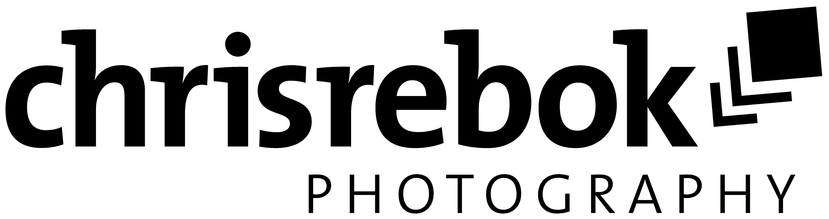

**Pressrelease**   
Don‘t publish before 01.09.2019

**Calendar for Winelovers**

South African Wineries – Wine architecture between tradition and modernity

The calendar "South African Wineries" reflects the breathtaking beauty of the Cape Winelands of South Africa and the variety of unique wineries. In an impressive way, the motifs carefully selected by wine photographer Chris Rebok show South African wine architecture between tradition and modernity.

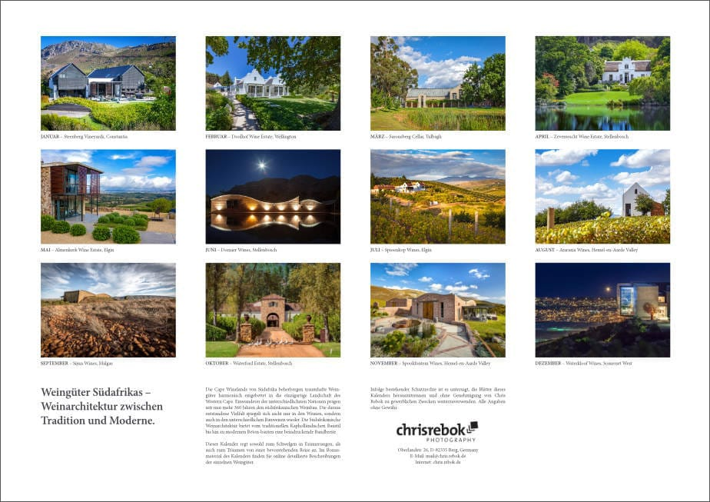  
Immigrants from various nations have been shaping South African viticulture for more than 360 years. The resulting diversity is reflected not only in the wines, but also in the different construction methods. South African wine architecture offers an impressive range from traditional Cape Dutch architecture to modern concrete structures.

This wine calendar is not only an ideal gift for wine lovers, wine enthusiasts or true wine connoisseurs, but also for those who enjoy beautiful wine landscapes, gorgeous wineries and impressive wine architecture.

With the bonus material available on the internet, shoppers get online access to a wealth of information about the wineries displayed.

The calendar “South African Wineries” encourages both reminiscing and dreaming of an upcoming journey.

**Bonus Material Online!**

The buyers of the calendar can not only enjoy the beautiful pictures, but get online access to a variety of information on the pictured wineries. Starting with the contact details with GPS information, the description of the winery to an overview of the top wines, there is everything that interests the ambitious wine lovers, or the curious wine travellers. The bonus material is available in both German and English.

**Participating Wineries:**

Almenkerk Wine Estate, Ataraxia Wines, Doolhof Wine Estate, Dornier Wines, Saronsberg Cellar, Sijnn Wines, Spioenkop Wines, Spookfontein Wines, Steenberg Vineyards, Waterford Estate, Waterkloof Wines, Zevenwacht Wine Estate.

**Calendar Versions and Prices:**

The calendars are digitally printed on high-quality, multi-coated, FSC-certified art paper. They have a cover picture, twelve different monthly motifs, an overview page (altogether 14 pages) and are spiral-bound. All calendars are equipped with a transparent folio cover and a sturdy cardboard back wall. It is available in a German version in A5 (desk calendar) and as a wall calendar in A4, A3 and A2 format and in an English version in A4 and A3 format. The prices are between 18,90 € and 49,90 €.

**Suppliers:**

The calendars are available on all popular online platforms such as BookButler, amazon.co.uk or BookDepository and can be ordered via the classic book trade by means of the respective ISBN number. From 10 pieces, calendars with individual advertising impression can also be obtained directly from Chris Rebok.

**Contact Details:**

Chris Rebok  
Tel. +49 8151 95190  
Mobil: +49 171 17 555 19  
mail@chris.rebok.de

<https://chris.rebok.de/kalender/>

**About Chris Rebok:**

Following a passion Chris Rebok‘s photographic focus is on the subject of wine. Starting with the vineyard, the winery, the wine itself, wine events, impressive wine architecture to lovely vineyard landscapes as well as wine-docus and wine reportage photography.

**Photo Material:**

Pictures can be found under https://chris.rebok.de/presse/

Please contact me if you need pictures in higher resolution.

**ISBN-NUMBERS:**

Weingüter Südafrikas DIN A5 landscape Desk Calendar – ISBN: 978-3-671-19764-4

Weingüter Südafrikas DIN A4 landscape Wall Calendar – ISBN: 978-3-671-19761-3

Weingüter Südafrikas DIN A3 landscape Wall Calendar – ISBN: 978-3-671-19762-0

Weingüter Südafrikas DIN A2 landscape Wall Calendar – ISBN: 978-3-671-19763-7

South African Wineries DIN A4 landscape Wall Calendar – ISBN: 978-1-325-48889-6

South African Wineries DIN A3 landscape Wall Calendar – ISBN: 978-1-325-48890-2